
Silver Panther Photo Booth Help Guide

Copyright © 2014 - 2025 Orbitami Entertainment. All rights reserved. This work is protected by copyright and may not be reproduced, distributed, or transmitted in any form or by any means without the prior written permission of Orbitami Entertainment. Unauthorized use of this material may violate copyright, trademark, and other applicable laws.

The following guide is to provide understanding on how to use the Silver Panther Photo Booth system.

Add the system to the scene
Right-Click in the Assets folder and select:
Orbitami Entertainment > Silver Panther Photo Booth > AddToScene

System UI – (In the inspector)

The System UI is the game or application UI that you have setup in your scene. It can be toggled on or off in the editor once it is assigned in the inspector. This is a quality of life feature. It enables a quick action for disabling unwanted UI elements in the editor Game View when capturing images.

Save As Sprite – (In the inspector)

When taking images in the editor you have the option of saving the captured image as a sprite. This feature is editor only.

Unity Save Location Folder – (In the inspector)

If you want to use the default path where the photo booth default output folder is located then click the "Set or update folder path location to default" button located in the inspector.

Local PC Path – (In the inspector)

You can enter a custom path to a folder on your local PC if you wish to save images there instead of inside Unity.

Screenshot Name – (In the inspector)

When the screenshot name type is set to Custom make sure to enter a name. Otherwise you can choose to use the Date & Time name type which utilizes the system date and time.

Screenshot Key – (In the inspector)

The screenshot key is the key the user will press at runtime to take a screenshot of the current screen they are viewing at runtime.

Toggle Controls – (In the inspector)

You can toggle the scene UI and Photo Booth using the controls located in the inspector in the section labeled Camera Control. Remember the System UI must be assigned in the inspector in order to toggle it.

Take Editor Screenshot – (In the inspector)

Located in the inspector you will find the Take Editor Screenshot button in the Camera Control section. When clicking this button the system will attempt to take a screenshot of the Game View window inside Unity. The Game View resolution is used as the resolution of the screenshot image. You can adjust the camera zoom, position, and lighting from within the Camera Control section.

Note:
If you intend to allow the user to set the name of the screenshot they take at runtime then you simply need to pass the name provided by the user into the SilverPantherEngine.cs method below:
SilverPantherEngine.TakeScreenShot();

Example Usage:

string screenshotName; (Can be set manually by the user via an input field)

SilverPantherEngine.TakeScreenShot(screenshotName);

Continue to see example script and usage:

Example Runtime Script:

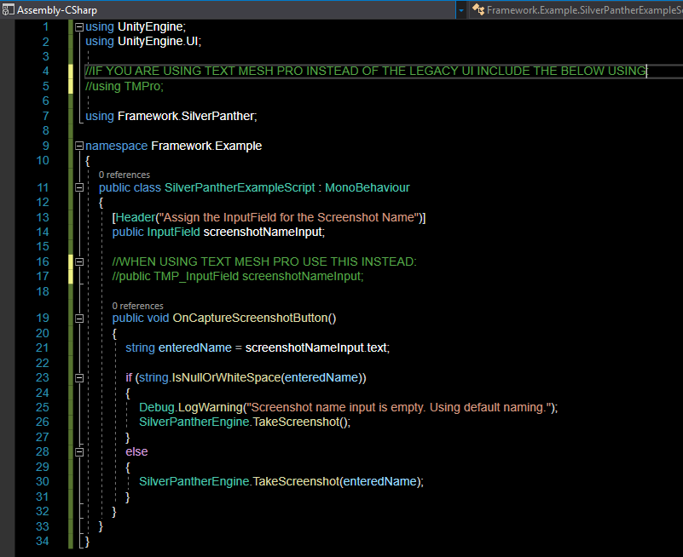
Usage Instructions for Developers:

- Create a Canvas with an InputField and a Button in your scene.
- Attach this script to a GameObject.
- Drag the InputField into the screenshotNameInput field in the Inspector.
- Assign the Button's OnClick() to call ScreenshotUIHandler → OnCaptureScreenshotButton.

